The Diamond Model:

Introductions:
In in the diamond model gives us the idea of analysis of the intrusion analysis.
It consists of the 4 core steps of starting from the
- Adversaries.
- Infrastructure
- Capability
- Victims
Through the diamond model we can integrate the cyber threat intelligence for real time network defense
Who is an Adversary?
The adversary is the group of a people or person or hacker that perform malicious activities against the victims or it target.

Adversary operator: is the person or hacker that are carrying these activities against victims to achieve its goals.

Adversary Customer: A group or organization that are controlling the different adversaries against their victims which have different capabilities and set of tools. But they can be a single person also.

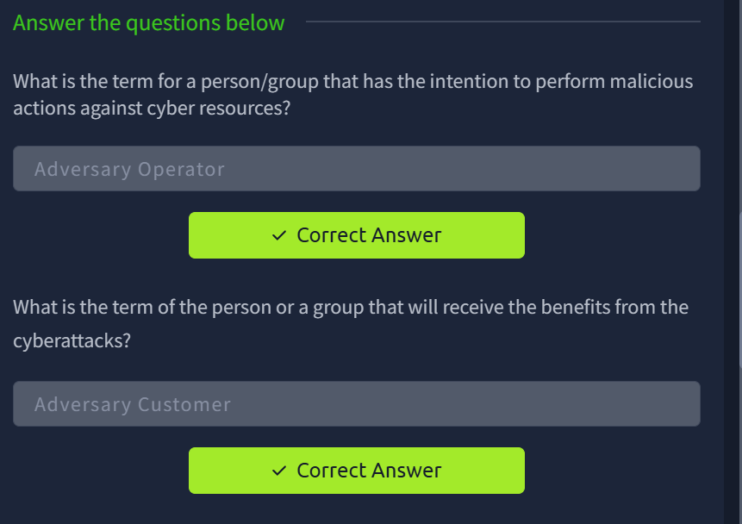

Victims:
For the hacker the victims are the person, organizations, ip address, any assets or domain name against which they perform cyber-attack.
For example in case of spear-phishing ( a method in which the specific group of people can be targeted through phishing emails).

There are 2 terms that can be used for the victim these are.

Victim Personae: the are people or organization group their assets can be exploited under attack by the adversaries.
Victim Assets: These are the attack surface that such as the Ip address, network or the email address, hosts, and social networking accounts etc. to which the adversaries will direct their capabilities.

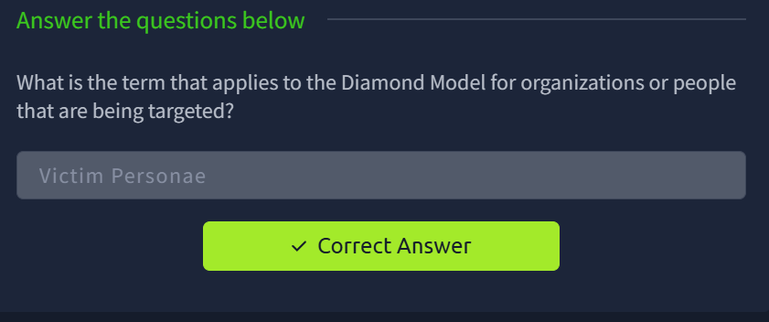

Capabilities:
Capabilities are the set of the skills, tools and techniques that the adversary can used against its victim. And these are called the TTP

Capabilities capacity: It is all of the vulnerabilities and exposure that an individual capacity can used from less sophisticated techniques such as weak password guessing to the advanced malware drafting.

Adversary Arsenal:
An Adversary Arsenal is a set of capabilities that belong to an adversary. The combined capacities of an adversary's capabilities make it the adversary's arsenal.
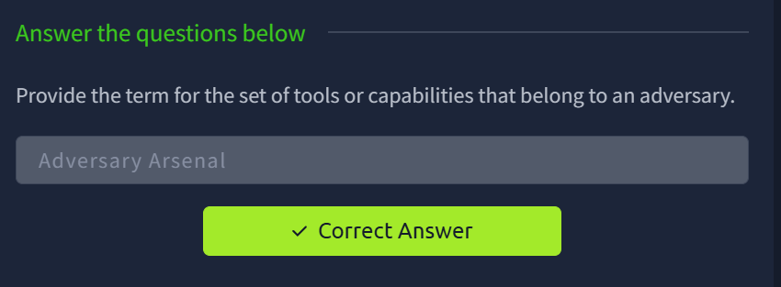

Infrastructure:
is a software or the hardware that the adversary can used to gain the control of the victim
Infrastructure can be the Ip address, network devices, software, hardware etc. and even a USB dropped in the street for malicious purpose.

There are 2 types of the infrastructure

Type 1 Infrastructure:
This type of infrastructure directly belongs to the adversary or controlled by it

Type 2 infrastructure:
This type of the infrastructure can be a intermediary and sometime the intermediary can know about the adversary and sometimes not. This method is used for the obfuscated techniques.

Service Providers are organizations that provide services considered critical for the adversary availability of Type 1 and Type 2 Infrastructures, for example, Internet Service Providers, domain registrars, and webmail providers.

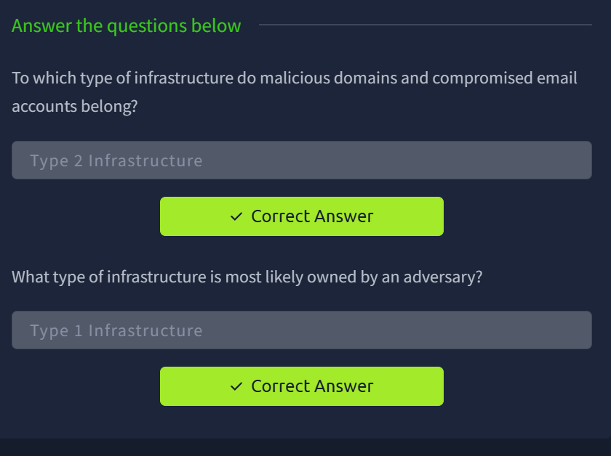

Event Meta Features:

Time Stamp:
The time stamps gives us the record about the event on which date it happen and how many time is occurs.

Phase:
These are the phases of the intrusion, attack or breach. Every malicious activity contains two or more phases which must be successfully carried out to perform the malicious activity.

Results:
It is crucial to capture the success result of the adversary attack against our organization sometimes the results are not known at the first stage. We can co-relate the events to carry out the results. These can me measured on the based of the CIA triad i.e., which one is compromised like the Confidentiality, integrity and availability.

Directions: In the directions we can understand the directions of the attack there are seven possible directions of the attack infrastructure to infrastructure , infrastructure to victim , victim to infrastructure, Adversary to infrastructure , infrastructure to adversary, Bidirectional or Unknown.

Methodology:
This will allow the general classification of instruction i.e DDOS, phishing, breach , port scan

Resources:
Every attacker needs resources to carry out its successful attacks.
These are software, hardware, fund , knowledge , access and motivations.

software (e.g., operating systems, virtualization software, or Metasploit framework), knowledge (e.g., how to use Metasploit to execute the attack and run the exploit), information (e.g., a username/password to masquerade), hardware (e.g., servers, workstations, routers), funds (e.g., money to purchase domains), facilities (e.g., electricity or shelter), access (e.g., a network path from the source host to the victim and vice versa, network access from an Internet Service Provider (ISP)).

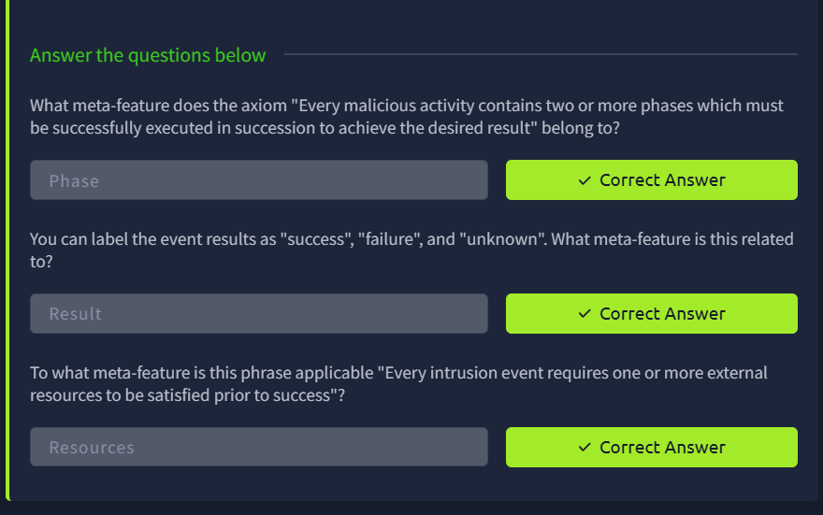

Social Political Components:
In the social political components can describes the intent and the need of the adversary for example gain of financial assets, acceptance in hacker community, hacktivism, or espionage.

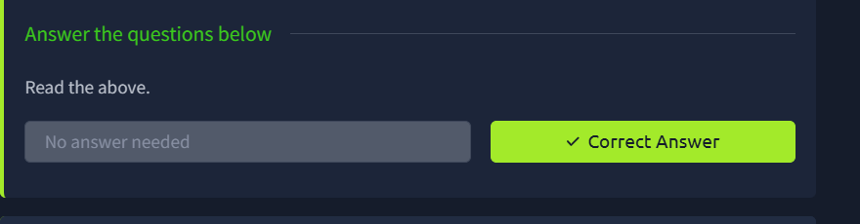

Technology components:
The technology components highlight the adversary capabilities and infrastructure. The capabilities and infrastructure give us the methodologies and techniques that the adversary can used in their attacks.
For example: A water Holing technique in which the adversary compromised the legitimate websites and redirects the victims that frequently used this website to its own malicious websites.

Practical Analysis:

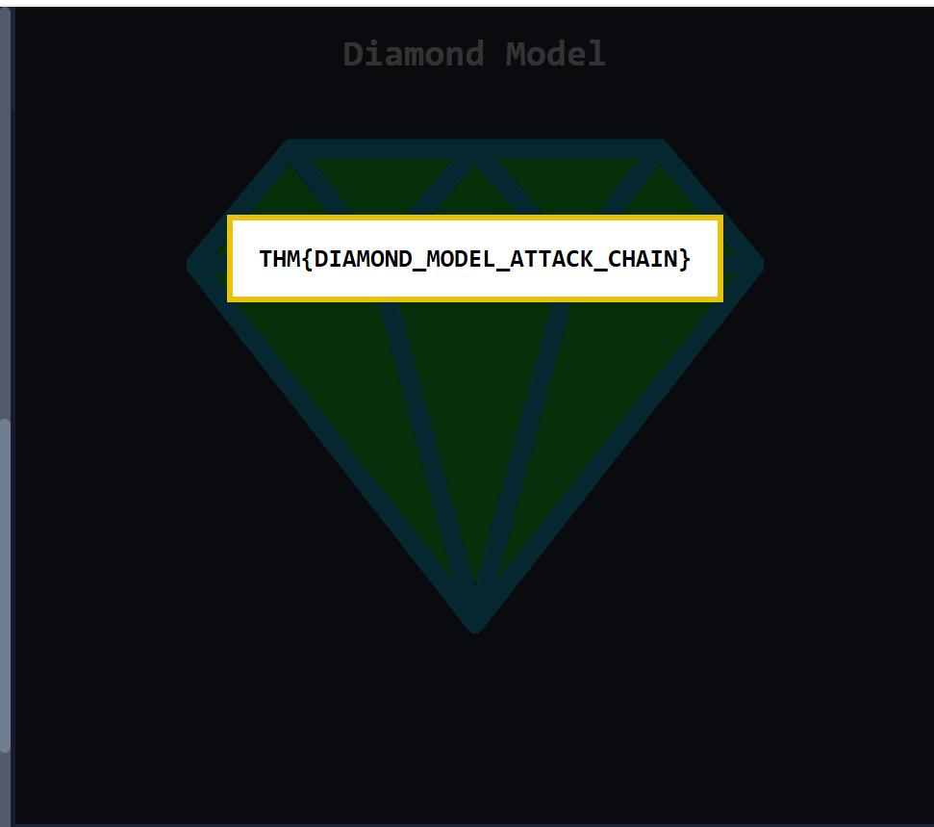

Conclusions:
now I am able to explain the diamond model to the C-Suite i.e the audience , customer , and clients

